**What is Docker Compose ?**



Docker Compose is a tool that simplifies the process of managing multi-container Docker applications. It allows you to define and run multiple Docker containers using a single configuration file, typically named `docker-compose.yml`.

**Docker Compose** vs. **Traditional Docker**:

1. **Managing Multiple Containers**:

- Traditional Docker: You need to manually start each container using individual `docker run` commands. Managing dependencies and networking between containers can become complex.

- Docker Compose: You define all your containers, their configurations, and their relationships in a single `docker-compose.yml` file. With a single command (`docker-compose up`), you can start and manage all containers together.

2. **Configuration in Code**:

- Traditional Docker: Container configurations are specified in the command line, making it harder to track and reproduce environments.

- Docker Compose: All configurations are written in the `docker-compose.yml` file. This file can be versioned, shared, and reused, ensuring consistency across environments.

3. **Networking**:

- Traditional Docker: Setting up networking between containers requires manual configuration.

- Docker Compose: Automatically creates a default network for all containers defined in the `docker-compose.yml`, making it easy for them to communicate with each other using service names.

4. **Simplified Commands**:

- Traditional Docker: Requires multiple commands to manage different containers.

- Docker Compose: Provides simplified commands like `docker-compose up`, `docker-compose down`, `docker-compose logs`, etc., to manage the entire application stack.

5. **Environment Management**:

- Traditional Docker: Managing different environments (development, testing, production) requires separate scripts or manual adjustments.

- Docker Compose: Supports multiple environments using different `docker-compose.yml` files or override files, making it easier to switch between environments.

**Summary**:

Docker Compose is a tool designed for defining and running multi-container Docker applications. It differs from traditional Docker by allowing you to manage all containers and their configurations in a single file (`docker-compose.yml`), simplifying the process of managing multi-container applications. This approach makes it easier to handle networking, configurations, and environment consistency, especially in complex applications with multiple services.

It uses YML file where all instructions and configuration are written in this file.

Docker Compose allow us to run entire application with a single command.which means:

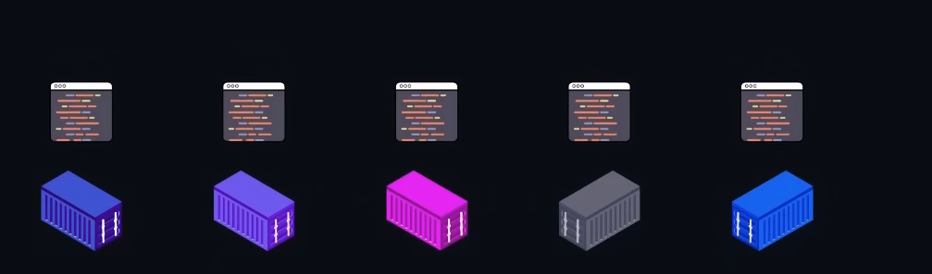

Now we don’t need to run al containers individually, It runs the entire app or we ca say multiple containers with a single command.

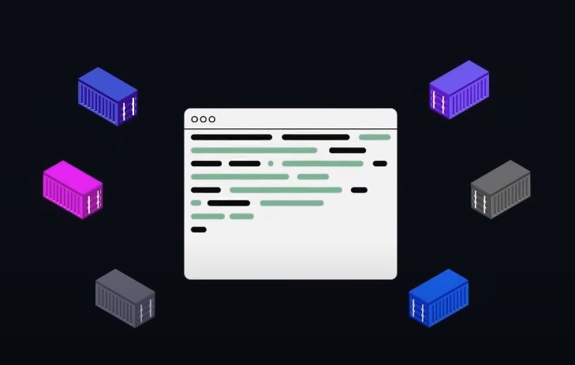

We can write all the instructions for running multiple containers in a single file also known as YML.

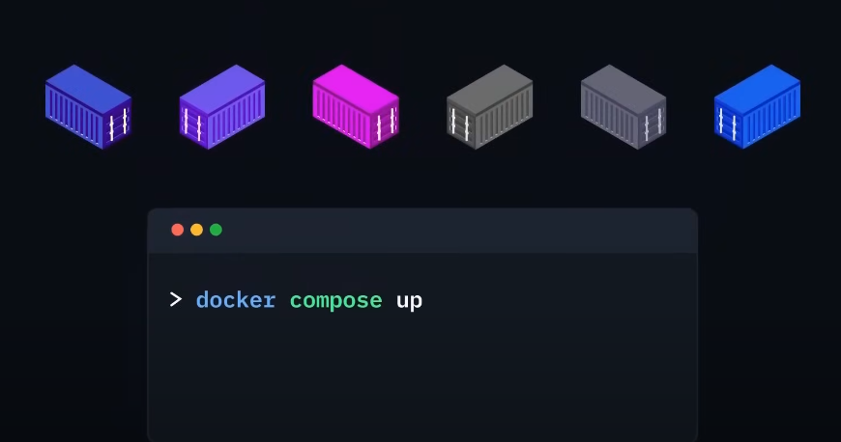

Then, by using this single command we can run all containers.

Now ab jo yeh files hum khud say bnatay thy Docker wil automatically create for us using the **Docker init** command.

Docker use CLI to generate these command for us . and it is called **Docker Init.**

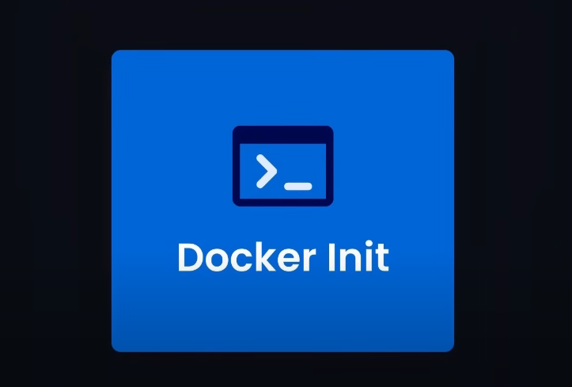

* By using **Docker init** we can initialize all the files that are require to run

our app A/c to the tech stack we are using.

**What is Docker Init ?**

Docker `init` is a command used to quickly set up a Docker project in your current directory. It creates a basic `Dockerfile` and other related files needed to containerize an application. This command simplifies the initial setup process by automatically generating the necessary configurations for you.

**\*\*Key Points About Docker Init**:**

1. **Automatic Dockerfile Creation**:

- Docker `init` automatically generates a `Dockerfile` based on the contents of your project. It analyzes the files in your directory and creates a `Dockerfile` with the appropriate configurations for the detected language or framework.

2. **Simplifies the Setup Process**:

- Instead of manually writing a `Dockerfile` from scratch, Docker `init` gives you a starting point. This is especially helpful for developers who are new to Docker or who want to quickly containerize an application.

3. **Language and Framework Detection**:

- Docker `init` tries to detect the programming language or framework used in your project (e.g., Node.js, Python, etc.) and creates a `Dockerfile` suited to that environment. This reduces the need for manual configuration.

4. **Additional Configuration Files**:

- Besides the `Dockerfile`, Docker `init` may also create other configuration files, such as `.dockerignore`, which tells Docker which files and directories to ignore when building the image.

5. **Interactive Prompts**:

- When you run Docker `init`, it might prompt you for certain options or configurations, allowing you to customize the generated `Dockerfile` based on your specific needs.

**Example Usage**:

To use Docker `init`, simply navigate to your project directory in the terminal and run:

```

docker init

```

This command will generate a basic `Dockerfile` and other necessary files in your current directory.

**Summary**:

Remember run **Docker init** in your project directory where you want to create **Docker file.**

Now lets create vite project using **Docker init :**

Ab jasay hi Docker init run ki toh it ask some questions after fulfilling it creates the **Dockerfile,dockerignore,Compose.yaml** , Dockerfile and dockerignore toh thk hai now we have to understand **compose.yaml** bcuz while working with **Docker compose** it is most important file.

services:

web:

build:

context: .

ports: - 5173:5173

volumes:

- . : /app

- /app/node_modules

Now explanation of above code:

This code is written in YAML format and is typically used in a `docker-compose.yml` file to define and configure services for a Docker Compose application. Let’s break it down:

**\*\*services:\*\***

- This is the top-level key in a Docker Compose file. It defines the different services (containers) that will be part of your application.

**\*\*web:\*\***

- This defines a service named `web`. The service represents a Docker container that will be created and managed by Docker Compose.

**\*\*build:\*\***

- This section specifies how the Docker image for the `web` service should be built.

**\*\*context: . \*\***

- The `context` key specifies the build context, which is the directory containing the Dockerfile. The dot (`.`) means the current directory where the `docker-compose.yml` file is located. Docker will look for a Dockerfile in this directory to build the image for the `web` service.

**\*\*ports:\*\***

- This section maps ports between the host machine and the Docker container.

**\*\*- 5173:5173\*\***

- This line maps port `5173` on the host machine to port `5173` inside the Docker container. This means that if you access `http://localhost:5173` on your host machine, it will connect to port `5173` inside the container, where your application is likely running.

**\*\*volumes:\*\***

- This section defines volume mounts, which link directories or files from your host machine to directories inside the Docker container.

**- . :/app**

- This line mounts the current directory (`.`) on your host machine to the `/app` directory inside the container. This means that any changes you make to the files in the current directory on your host machine will be reflected inside the container, and vice versa.

**- /app/node_modules**

- This line creates an anonymous volume specifically for the `/app/node_modules` directory inside the container. It prevents the `node_modules` directory inside the container from being overwritten by an empty `node_modules` directory from your host machine. This is useful to ensure that the container uses its own `node_modules` and doesn’t get affected by the host's file structure.

Now by doing this Docker compose solves our some problems:



1. First , it solves the problem of updating code in Docker container which means that now when we make changes in code in our working directory in local machine so it will reflect in Docker container as well this is due to the **Volume bind mount** which we have done in above code.
2. Second, it allow us to manage multiple container in a single file.
3. Third, it builds and run the image by itself.

But there one thing left, wo yeh kay agar hum package.json file ma kuch change kreinga toh wo automatically change nhi krega. Now to solve these problems we have another feature known as **Docker Compose Watch.**



Docker Compose Watch basically listen to our changes which we done in app and make some changes like:

* Rebuilding our app
* Rerunning the container and much more.
* It’s a new feature that automatically updates our containers.

Docker Compose Watch is a tool or feature used to automatically rebuild and restart Docker containers when files in the project are changed. This is particularly useful in development environments where you want to see the effects of your code changes in real-time without manually rebuilding and restarting the containers.



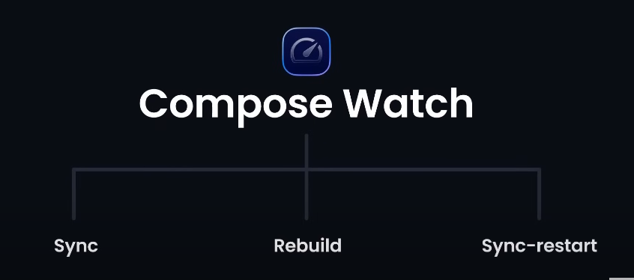

Above are the main three features of Docker Compose watch

Explanation of the Main Features of Docker Compose Watch:

**\*\*1. Sync**:**

- **Sync** refers to the feature that automatically synchronizes files between your local development environment and the running Docker containers. When you make changes to your code or configuration files on your local machine, those changes are immediately reflected inside the container without needing to rebuild or restart it. This ensures that the development environment inside the container stays up-to-date with the latest changes from your local machine.

**\*\*2. Rebuild**:**

- **Rebuild** is the feature that triggers a rebuild of the Docker image whenever significant changes are detected in your project files (such as changes to the `Dockerfile` or files that affect the application’s build process). After rebuilding the image, Docker Compose Watch can automatically restart the container with the new image, ensuring that your application runs with the latest code and dependencies.

- As you know in simple Docker Compose jo code may changes hotay thy wo toh reflect hojatay thy Docker container may, but jo changes package.json file may hotay thy or asi file may jiska affect Image building time pay application may hota hai unmay jo changes hotay thy wo reflect nhi hotay thy bcuz unkay liya zarori hai kay dubara say build create ho and in simple **Docker compose** we have to do it explicitly but in **Docker compose watch** jasay hi koi iss type ki file may change hota hai that is going to affect app on build time so automatically re-build start after building new Image, container be automatically start hojata hai.

**3. Sync-Restart**:

- **Sync-Restart** is a combination of the sync and restart processes. When changes are detected that don’t require a full rebuild (such as changes in source code files that don’t affect the base image), Docker Compose Watch can sync those changes to the container and automatically restart the affected services or containers. This allows your application to pick up changes without the need for a full rebuild, making the development process faster and more efficient.

Q- but here is my question that agar jo sync and sync-restart dono jab code may chnges hotay hain toh wo changes reflect krdetay hain , so whats main difference b/w them ?

**Difference Between Sync and Sync-Restart:**

**\*\*Sync**:**

- **What It Does**: The Sync feature in Docker Compose Watch automatically synchronizes changes made to your local files with the corresponding files inside the running Docker container. This process happens in real-time, meaning as soon as you save a file, the changes are instantly reflected inside the container.

- **When It’s Used**: Sync is typically used for changes that don’t require the application or service to restart. For example, updating static files like HTML, CSS, or simple JavaScript files where the running process can pick up the changes without needing a restart.

**\*\*Sync-Restart**:**

- **What It Does**: Sync-Restart also synchronizes changes made to your local files with the container, but with one key difference: it automatically restarts the affected service or container after syncing. This restart ensures that the application processes the updated files correctly, which might be necessary for changes that require the application to reload or reinitialize.

- **When It’s Used**: Sync-Restart is used when the changes you make need the application or service to restart to be fully applied. For example, when you update configuration files, install new dependencies, or make changes that the application can’t apply on-the-fly without restarting.